US Patent Patent No.:
Date of Patent:

SU MAP
Inventors: Ankit Pandey(NPL)
Vishal Kumar(IND)
Surbhi Rawat(IND)
Ashish Kumar(IND)
*Notice: Subject to any disclaimer, the term of this
patent is extended or adjusted under 35
- S.C. 154(b) by 0 days.
Appl. No:
Filed:
Prior Publication Data:
Related Application Data
Provisional application No. ____, filed on _____.
Int. Cl.

Field of Classification Search .............

References Cited
PATENT DOCUMENTS

(Continued)

Abstract
Our college-focused website redefines destination discovery by leveraging the power of videos. This user-friendly platform empowers students to easily locate and explore their desired academic institutions with the help of video content. You can access an extensive collection of location-specific videos that provide visual insights into colleges and universities. Whether you're considering your next educational step, planning campus visits, or exploring potential universities, our website enriches the decision-making process by offering an immersive preview of campus life, facilities, and the overall environment. Move beyond static brochures and websites, and get a firsthand feel for your academic destination, making more informed choices.
Say goodbye to static maps and lengthy descriptions; with our website, you can now see, experience, and connect with your desired destinations in a more engaging and informative way.
Keywords: Navigation using Video,360° Videos, .

.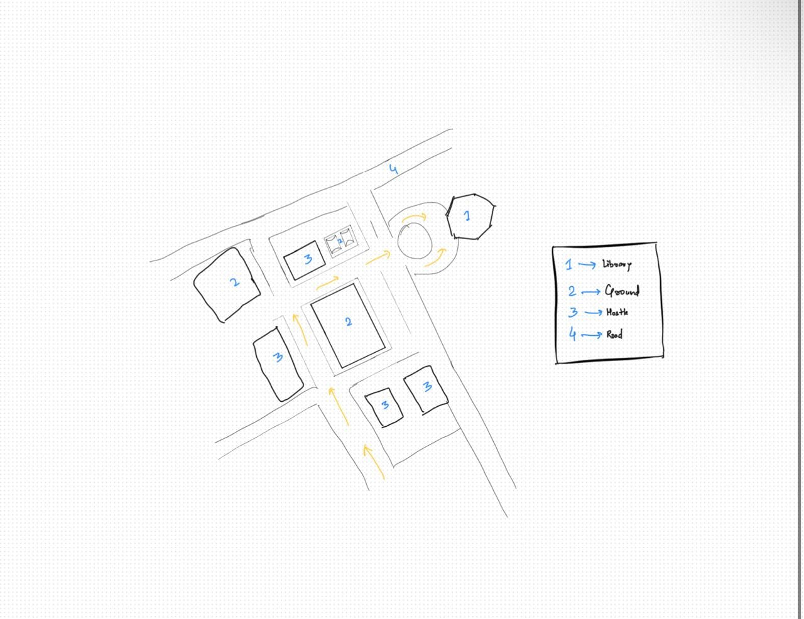
Claims:
claim 1: A computer-implemented system for a college navigator using videos, comprising:
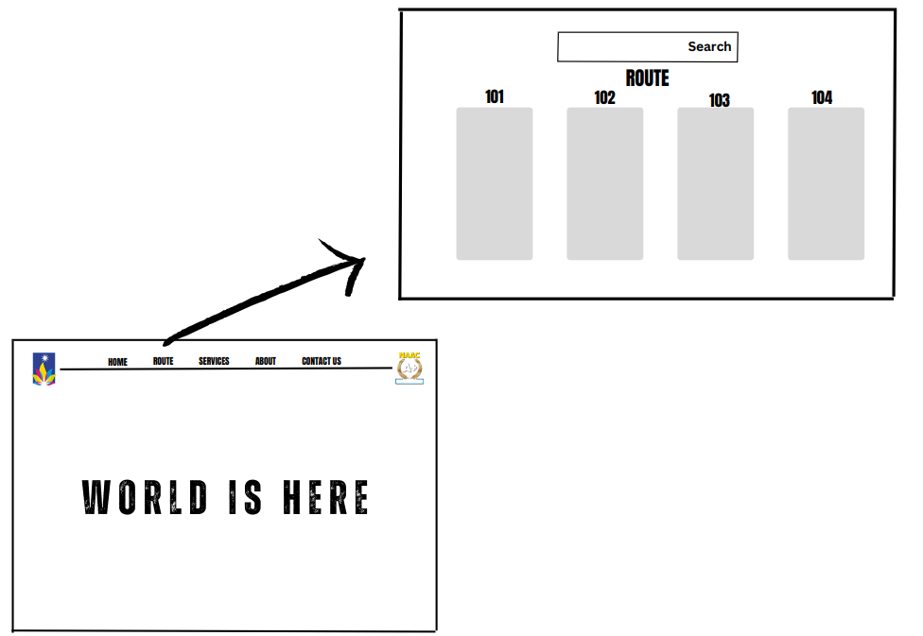
A user interface accessible via the internet or other network(fig:1), enabling users to search for and locate information regarding colleges and universities. A database containing a collection of location-specific video content, each video offering visual insights into various academic institutions, encompassing campus facilities, academic programs, and campus life.A search and recommendation engine that facilitates user searches and retrieval of video content based on user-defined criteria, including location, academic majors, and campus features. An interactive mapping feature, which allows users to visualize the geographical locations of colleges and universities on a map and access video content associated with specific geographic points. User engagement tracking and analytics to monitor and analyze user interactions with the video content and the website for system optimization
Fig:1

and personalization. A user profile management system, enabling users to save, share, and record preferences, interactions, and video content related to their college navigation.
Claim 2: A computer-implemented system for a college navigator using videos, as claimed in claim 1, further comprising:*
An augmented reality (AR) feature that allows users to view video content overlaid on real-world images of academic institutions using AR-capable devices. A social integration component enabling users to share and collaborate on college selection and exploration by connecting with friends, family, or peers .A machine learning algorithm that provides personalized recommendations for colleges and universities based on user interactions, preferences, and historical usage data. A feedback system, allowing users to rate and review video content and academic institutions, contributing to a dynamic user-generated feedback ecosystem. This additional claim extends the functionality of the "College Navigator Using Videos" invention, incorporating augmented reality, social integration, machine learning, and feedback mechanisms. It seeks to protect these added features and their combination with the previously claimed elements
This patent claim seeks to protect the unique functionalities and features of the "College Navigator Using Videos" invention, preventing unauthorized duplication or use.[1]

RELATED APPLICATIONS
There are several applications and platforms available in the market that are related to the context of college navigation and exploration using videos.
CampusTours – CampusTours is a platform that offers virtual tours of colleges and universities. It provides video tours, interactive campus maps, and other resources to help prospective students explore campuses from the comfort of their own devices.
YouVisit - YouVisit is a platform that offers virtual reality (VR) campus tours and 360-degree videos of college campuses. It allows users to immerse themselves in the campus environment and get a better feel for what different colleges have to offer.
Background of the Invention
College campuses often have a vast and complex layout, making navigation challenging for students, faculty, and visitors. Existing methods for navigation within colleges are inefficient and often require a significant amount of time and effort. The College Navigation using videos is designed to provide an efficient and user-friendly navigation solution within college campuses.

Summary of the Invention
This innovative website transforms the college selection process by offering a user-friendly platform enriched with location-specific video content. It enables users to virtually explore campuses, find colleges that match their preferences, and make informed decisions. Interactive mapping, personalized recommendations, and additional tools enhance the experience, simplifying the path to the right educational institution. This immersive approach empowers students to select colleges that align with their goals and aspirations, revolutionizing the college application and decision-making process.[2]

Detailed Description of the Invention
1.System Architecture & Method of Operation
The College Navigation comprises:
User Interface: The system features a user-friendly web interface accessible via the internet. Users can access the platform from their computers, smartphones, or other internet-enabled devices. The interface is designed for intuitive navigation and ease of use.
Database:At the core of the system is a vast and continuously updated database of location-specific video content. This video content showcases various colleges and universities, offering visual insights into the academic institutions, their campuses, facilities, academic programs, student life, and more. These videos serve as an invaluable resource for prospective students to virtually visit and explore different colleges.
Search and Recommendation Engine: The system incorporates a powerful search and recommendation engine. Users can input their preferences and criteria, such as location, academic majors, campus culture, and extracurricular activities. The engine provides tailored search results and recommendations based on these inputs, helping users identify colleges that match their interests and goals.Communication Module: Facilitates real-time communication between the user's device and the navigation system.
Interactive Map Overlay: To enhance the geographic understanding of colleges and universities, the system includes an interactive map overlay feature. Users can visualize the locations of colleges on a map and access video content associated with specific geographic points. This feature provides a spatial context for the exploration process.
User Engagement Analytics: The system employs user engagement analytics to monitor and analyze user interactions with the platform. This data is crucial for improving the system's recommendations and overall user experience. It allows for continuous refinement and optimization based on user behavior and preferences.

User Profiles: Users have the option to create personalized profiles. These profiles enable users to save their favorite videos, record their interactions with the system, and receive customized recommendations. User profiles enhance the personalization and user-friendliness of the platform.
Additional Tools: Depending on the system's specific implementation, it may offer additional tools such as financial planning assistance, integration with academic calendars for application deadlines and campus visits, and social networking features that facilitate direct communication with college representatives, current students, or peers.
2. Technologies Employed
The College Navigation employs various technologies, including but not limited to:
Video Streaming Technology
Web Development Technologies
Mobile Application Development
Social Media Integration

Field of Invention
The field of invention for "College Navigation Using Videos" primarily falls within the realm of Educational Technology and Digital Media Exploration. This innovative concept blends elements of educational technology, multimedia, and information technology to enhance the college research and selection process for prospective students. It leverages video content to create an engaging and informative platform that simplifies the exploration of higher education institutions.

Flowchart
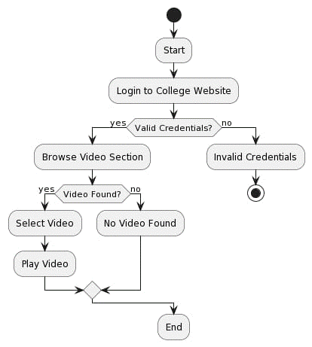
Conclusion
College Navigation Using Videos represents a transformative concept that harnesses the power of multimedia and technology to redefine the way students explore and select higher education institutions. By offering an immersive and visual approach to college research, the system empowers prospective students to make well-informed decisions about their academic futures. This innovative approach simplifies the college selection process, enhances the user experience, and bridges the information gap that often exists when choosing a college. It provides students with a dynamic platform for exploring campuses, academic programs, and campus life through engaging video content. Additionally, interactive mapping, user personalization, and recommendation features make the process more efficient and tailored to individual preferences .College Navigation Using Videos is at the forefront of educational technology and digital media exploration, offering a valuable resource for students embarking on their higher education journey. It not only facilitates better matches between students and colleges but also fosters a deeper understanding of the available options, ultimately contributing to more successful and satisfying educational experiences. As technology continues to advance, this innovative concept holds the potential to revolutionize the college application and decision-making process, making it more accessible, informative, and user-friendly for students worldwide.[3]

REFERENCES
- https://www.uspto.gov/
- https://ieeexplore.ieee.org/
- https://chat.openai.com/
- https://eprints.qut.edu.au/62476/1/ozchi2013long-camready.pdf
- https://www2.cs.sfu.ca/~jcliu/Papers/RoadNavigation.pdf
- https://www.mdpi.com/2076-3417/13/17/9508/pdf
- https://www.researchgate.net/publication/269197777_Android_Mapping_Application
- https://link.springer.com/chapter/10.1007/978-3-642-34203-5_13
- https://dl.acm.org/doi/10.1145/3488838.3488876
- https://ir.unimas.my/1318/1/syahrul+nizam+junaini+FINAL+-+for+iris.pdf
- http://repository.library.carleton.ca/downloads/hd76s028j

